For Immediate Release

News From: Absolute Machine Tools, Inc.
7420 Industrial Parkway Drive, Lorain, OH 44053
Contact: Courtney Ortner cortner@absolutemachine.com
With Art: Johnford SL-300L-II
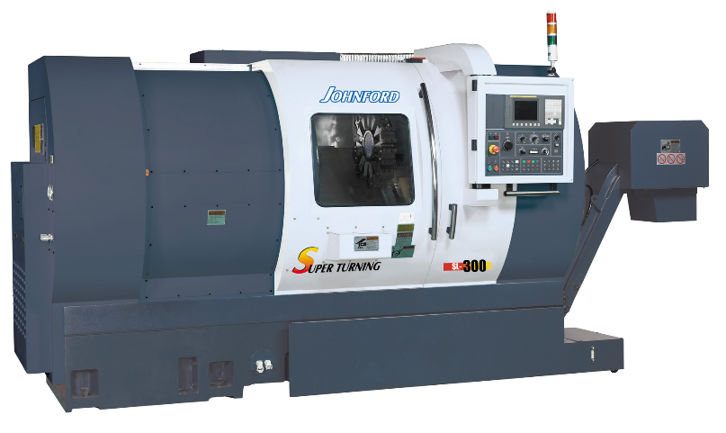
CAPTION: NEW SL-300L-II Super Slant Bed 30 degree Turning Center

Lorain, Ohio, February , 2024 – Introducing the NEW Johnford SL-300L-II slant bed turning center with extended 40” turn length for longer part turning. Since 1979, Johnford’s SL Series lathes have been constructed with a one-piece Meehanite cast iron base for not only intense strength and added rigidity, but also to dissipate heat away from the part improving dimensional accuracy. Johnford still hand-scrapes their box ways and coats all mating surfaces with Turcite-B for exceptional fit, mobility, and precision. The SL-300L-II ballscrews are double nut type and pretensioned to eliminate thermal growth. The 30˚ slant bed design allows for improved chip removal away from the work envelope and workpiece, space efficiency for more compact footprint design, and improved operator ergonomics for better part visibility and accessibility to cutting tools.

While all the above factors make the new Johnford SL-300L-II turning center an excellent choice, there are more attractive standard features such as:
- List price: $142,000 (incl. everything above and below)
- 22.8” Swing over Bed Design
- 17.7” Swing over Cross Slide
- 2” Bar Capacity
- 40” Turn Length
- 20 HP
- 8” 3-Jaw Hydraulic Chuck
- 12” Tool Turret
- 787 IPM Rapid Traverse
- Fully Programmable Tailstock, and
- DUAL HYDRAULIC STEADY RESTS

Also included in the new SL-300L-II is a 12-station bi-directional servo turret or optional BMT-55 servo live turret with 7.5 HP milling motor providing .2 second indexing as well as coolant through the tool holders. In addition to the live tooling option, a true linear Y axis is also available for off-center milling operations. Our Y axis is perpendicular to X in a right-angle design, providing true linear Y axis movement. Fanuc OiT-F Plus CNC control with 10.4” color LCD, full MDI keypad, Manual Guide i Conversational are all standard accessories to complement this new machine model.

The precision spindle structure is mounted using precision double row roller bearings in conjunction with angular contact ball bearings for high rigidity and accuracy. The spindle quill inner and outer linings are precision ground for fine fitting with the spindle, thus ensuring extreme concentricity and accuracy. Three spindle configurations are available to suit any machining requirement:
- 1.7” bar capacity, 6,000 RPM spindle
- 2” bar capacity, 4,500 RPM spindle
- 3” bar capacity 4,000 RPM spindle

Optional accessories include an automatic tool presetter, radial and axial live tool heads, contouring C axis with live tools, and much more. The C-axis accuracy is 0.001 degrees. The live tooling used for the C-axis is backed by a 7.5 HP spindle motor.

Add our SPECIAL PRODUCTIVITY PACKAGE which includes either a TRACER V-65E 4’ pneumatic bar loader, Vs-65E 4’ servo bar loader, or a TRACER Vs-80L 5’ servo bar loader, parts catcher, and parts conveyor for unattended operations. For more information or a quote on the new Johnford SL-300-II, email Absolute Machine Tools at info@absolutemachine.com.

###

